**Exercise: Appending two tables**

[OtherSales](https://d3c33hcgiwev3.cloudfront.net/pl5p8m3nTEC8Vcd_ScC_qg_c22945e0043c4f33adeab731851cc5e1_OtherSales.xlsx?Expires=1709769600&Signature=IDjSYsWOiQnF9dyP8TQ8qPH6RJMZJSoy6YGvhdq8yXE8Erz9JSGjA0qCTvyc~Y49tePYw39g9HhM-FXEKpj1JY5LzaTC-hA24F2VUNbp40ha1pavCVf~7IOou0Y0Hf7brmpUrYJxAkHNNh5OYS8EKlXJAJw1i5z3PZLtmmzutFs_&Key-Pair-Id=APKAJLTNE6QMUY6HBC5A" \t "_blank)

[XLSX File](https://d3c33hcgiwev3.cloudfront.net/pl5p8m3nTEC8Vcd_ScC_qg_c22945e0043c4f33adeab731851cc5e1_OtherSales.xlsx?Expires=1709769600&Signature=IDjSYsWOiQnF9dyP8TQ8qPH6RJMZJSoy6YGvhdq8yXE8Erz9JSGjA0qCTvyc~Y49tePYw39g9HhM-FXEKpj1JY5LzaTC-hA24F2VUNbp40ha1pavCVf~7IOou0Y0Hf7brmpUrYJxAkHNNh5OYS8EKlXJAJw1i5z3PZLtmmzutFs_&Key-Pair-Id=APKAJLTNE6QMUY6HBC5A" \t "_blank)

[AdventureWorksSales](https://d3c33hcgiwev3.cloudfront.net/vI_S5iVOSr6M1jy3wz6x6Q_d72446391fc34bb09f3d25edbd9a3ae1_AdventureWorksSales.xlsx?Expires=1709769600&Signature=c~aC-qkxktvPQQiuF4Yat9JdTiga7o-gmTupnhxvyQv0cx~UMiY9BTpE0TgrIsgHOFwtjgoj3RQpzq~39DUvcErB8gkKdoGViwi8i2yRPcJ-81XnTMd7VtuHnHlcU~CRK-rUCQ2MKzwQ8ceJ2hX5Ue7-uez7X9G1YsdN1AqjLqw_&Key-Pair-Id=APKAJLTNE6QMUY6HBC5A" \t "_blank)

[XLSX File](https://d3c33hcgiwev3.cloudfront.net/vI_S5iVOSr6M1jy3wz6x6Q_d72446391fc34bb09f3d25edbd9a3ae1_AdventureWorksSales.xlsx?Expires=1709769600&Signature=c~aC-qkxktvPQQiuF4Yat9JdTiga7o-gmTupnhxvyQv0cx~UMiY9BTpE0TgrIsgHOFwtjgoj3RQpzq~39DUvcErB8gkKdoGViwi8i2yRPcJ-81XnTMd7VtuHnHlcU~CRK-rUCQ2MKzwQ8ceJ2hX5Ue7-uez7X9G1YsdN1AqjLqw_&Key-Pair-Id=APKAJLTNE6QMUY6HBC5A" \t "_blank)

**Introduction**

By now, you should have a good understanding of the concept of combining data and its practical applications. You covered the two primary data combining operations, append and merge. You initially focused on appending data. In this exercise, you will have the opportunity to apply your knowledge by using Power Query to append rows, allowing you to consolidate data and simplify data management.

**Case study**

Adventure Works has recently acquired another bicycle business. Adventure Works’ CEO, Jamie Lee, has assigned a task to the sales department to ensure that the sales data from the newly acquired business is reported in the Adventure Works sales reports. Your manager, Adio Quinn, has tasked you with creating a Power BI query that merges the data.

The company provided the two Excel files containing the Adventure Works sales data, *AdventureWorksSales.xlsx* and the new company’s data, *OtherSales.xlsx*. The datasets have some common data such as **SalesOrderID**, **SalesOrderDetailID**, **UnitPrice** and **SalesData** as well as columns with different names. As you learned in previous videos, in tables that will be combined, the column names that you want to stack vertically should be the same. For columns with matching names, their row values are stacked vertically to merge them, while for columns that exist separately in each set, they will be added horizontally, with null values for tables where those columns were not present before. To complete your task successfully you have to rename the common columns and give them the same names. You also have to remove any unnecessary columns.

This exercise aims to assist you in understanding how to combine data by appending data. By the end of this exercise, you’ll understand how to append data in Power Query, add rows together and consolidate data.

**Instructions**

Create a new Power BI project called **Exercise – Appending a dataset.** Follow the prompts below to complete the exercise.

**Step 1: Download the Excel files**

* Download the *AdventureWorksSales.xlsx*and OtherSales.xlsx files, which you will use in this exercise.

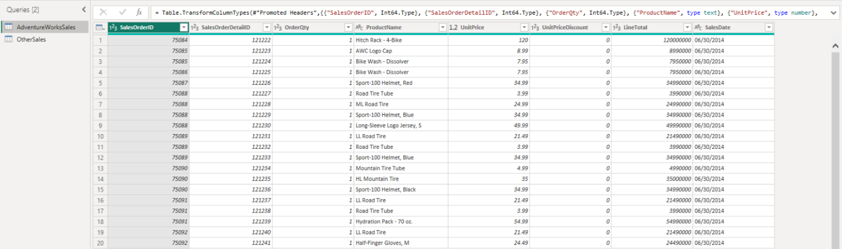

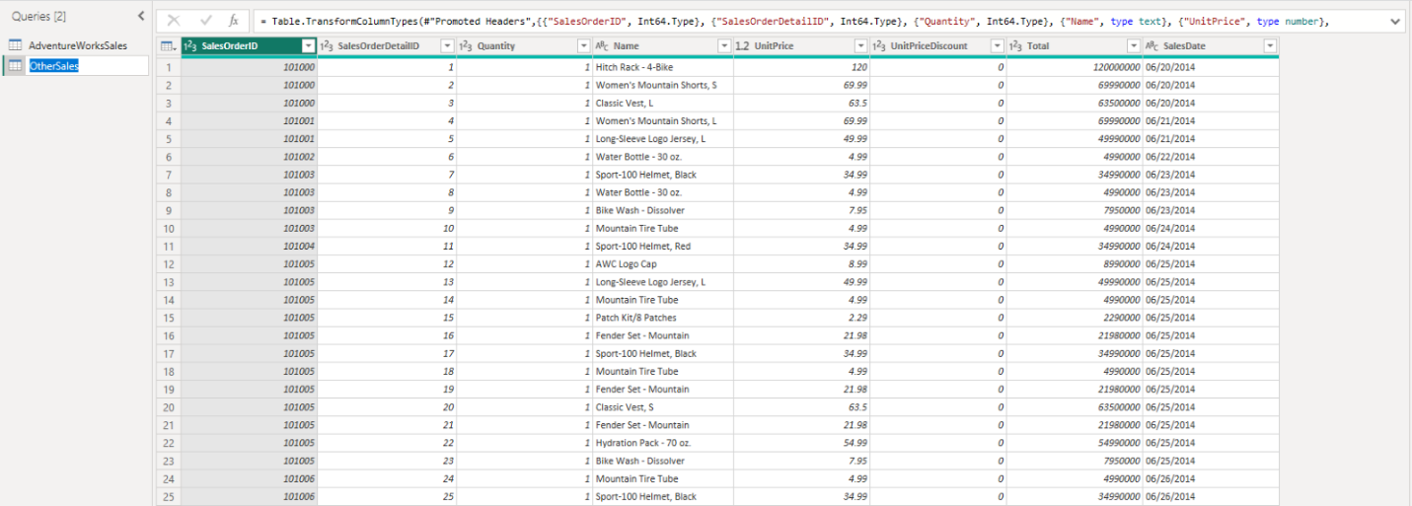

**Step 2: Open the Power Query Editor**

* Open the Power Query editor and import your datasets, *AdventureWorksSales* and *OtherSales*.

**Step 3: Format Excel files**

* You have to append *OtherSales* data to *AdventureWorksSales* data. So, you will use *AdventureWorksSales* data as the first table and *OtherSales* data as second table.
* For this reason, format the *OtherSales* data and rename the column names, using the *AdventureWorksSales* data, for example, **Quantity** to **OrderQty**, **Name** to **ProductName**, and **Total** to **LineTotal**.

**Step 4: Append queries**

* Append queries in a new master table. In the newly created query, check the column names, row number and the values appended. Make sure that the operation has been completed successfully.

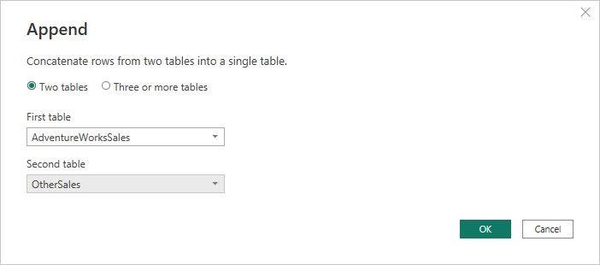

**Step 5: Rename new query**

* In the left menu, select the new query and change its name to *Consolidated Sales* and select **Enter** on the right pane, named **Properties**.

**Conclusion**

You have now successfully combined your datasets using Power Query. The data sets are now consolidated in one file, ready for further analysis in Power BI Desktop.

1. [Week 2](https://www.coursera.org/learn/extract-transform-and-load-data-in-power-bi/home/week/2)
2. Exemplar: Appending two tables

[Previous](https://www.coursera.org/learn/extract-transform-and-load-data-in-power-bi/quiz/NZvIc/self-review-appending-two-tables)[Next](https://www.coursera.org/learn/extract-transform-and-load-data-in-power-bi/quiz/PpRw8/knowledge-check-advanced-data-transformations-in-power-bi)

**Exemplar: Appending two tables**

**Overview**

In the exercise *Appending two tables,* you put into practice your understanding of how to combine a data set by importing, formatting, and appending data in Power Query.

Your objective for this exercise was to prepare a worksheet for analysis by completing the following tasks:

* Download Excel Files
* Open Power Query Editor
* Format Excel Files
* Append Queries
* Rename the New Query

This reading provides a step-by-step guide for completing these tasks, accompanied by screenshots for easy comparison with your own copy.

**Step 1: Download Excel files**

* Download *AdventureWorksSales.xlsx* and *OtherSales.xlsx* files**,** which will be used in this exercise.





**Step 2: Open the Power Query Editor**

Open the Power Query editor and import your datasets, *AdventureWorksSales* and *OtherSales*.

1. Navigate to the **Home** ribbon tab at the top of the **Power BI** window.
2. Select the **Excel Workbook** button inside the **Data** group, in the middle of the toolbar.
3. Select *AdventureWorksSales.xlsx* and *OtherSales.xlsx files* respectively and select **Transform Data** in the opened window.

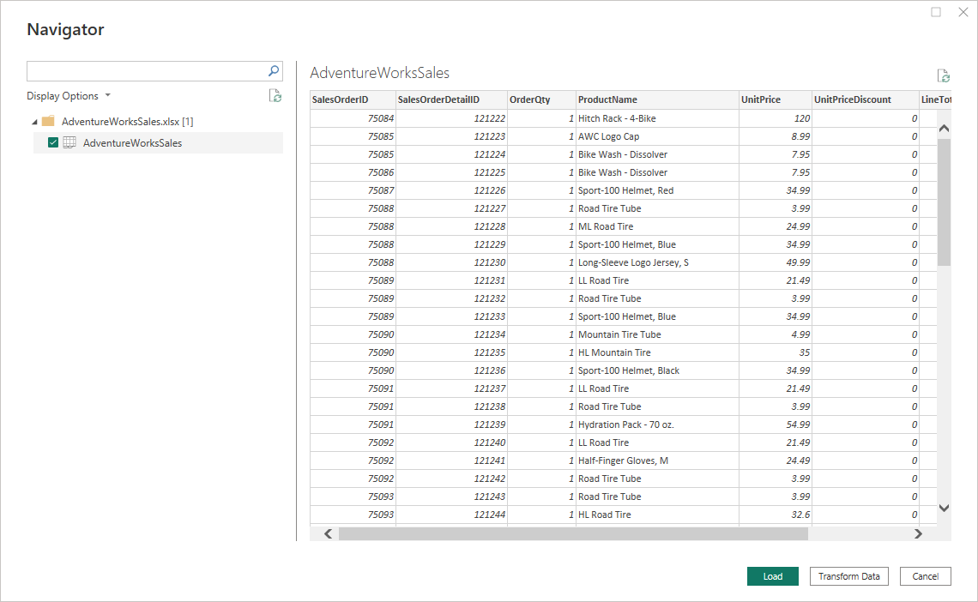

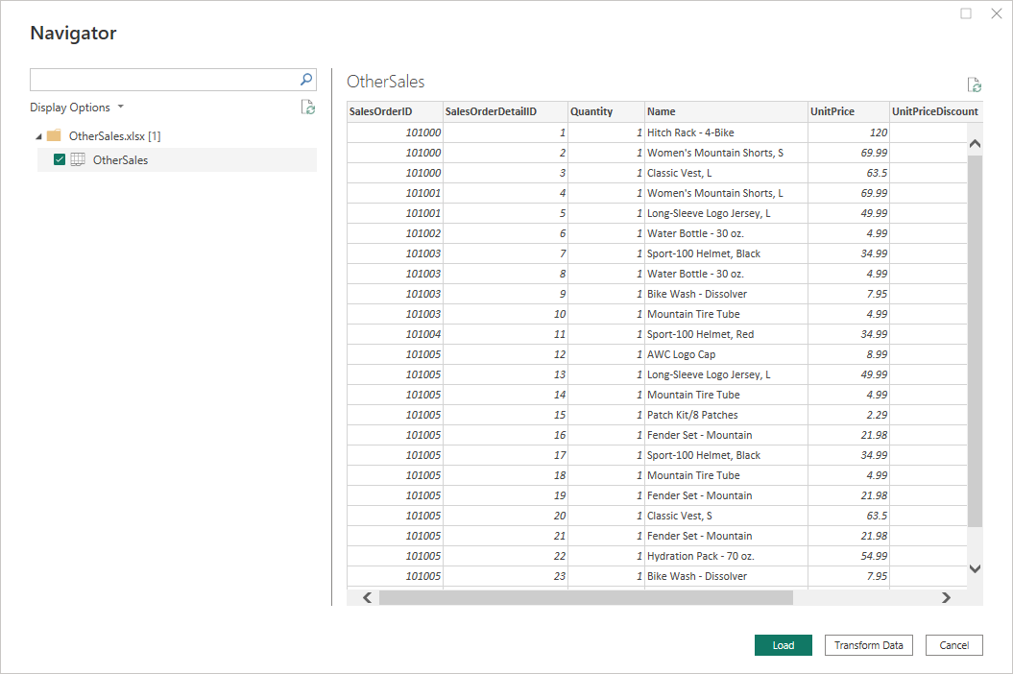

1. The **Power Query Editor** window opens. You can now begin formatting the data.

**Step 3: Format Excel files**

You will append *OtherSales* data to *AdventureWorksSales* data. So, you will use *AdventureWorks s*ales data as the first table and *OtherSales* data as the second table. For this reason, format *OtherSales* data and rename the column names to the same names as the column names in *AdventureWorksSales* data.

1. Select the **OtherSales**query in the **Query** pane at the left menu of the **Power Query** window.
2. Rename the **Quantity** column to **OrderQty** by selecting the column.

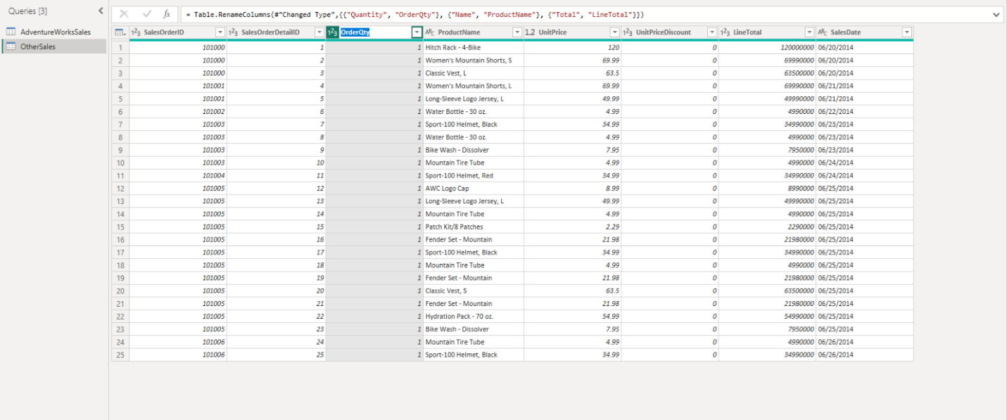

1. Repeat the same changing operation for the column **Name** to **ProductName**.
2. Change the column **Total** to **LineTotal**.

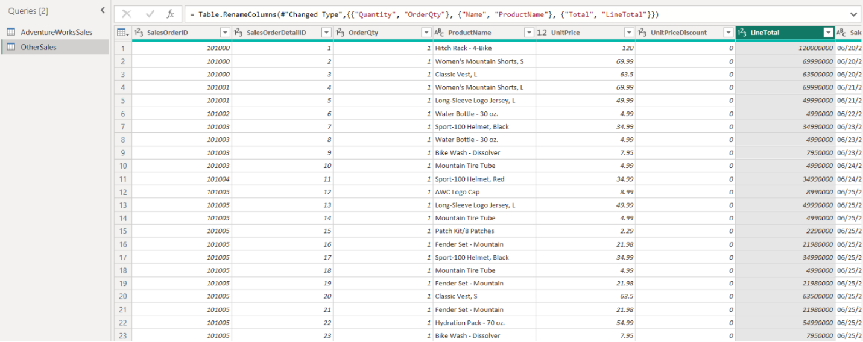

**Step 4: Append queries**

Append queries in a new master table.

1. Select the **Append Queries** dropdown menu inside the **Combine** group, in the **Home** ribbon bar.

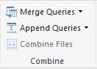

1. Select **Append Queries as New** from the **Append Queries** dropdown menu.
2. Select the **Two Tables** radio button. Select **AdventureWorksSales** as the first table and **OtherSales** as the second table.



1. Alternatively, you can select the **Three or more tables** radio button and use the drag and drop functionality. You can also select the tables you want from **Available Tables** and add them to **Tables to Append**.

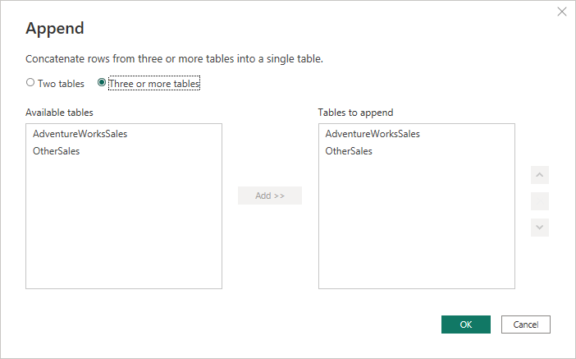

1. Find the new query named *Append1* on the left menu **Queries** pane.
2. Check the column names, row numbers, and the format of the appended query. Verify that there are 8 columns and 124 rows at the bottom left in the status bar.



**Step 5: Rename new query**

Change the name of the new query to *Consolidated Sales*.

1. In the left menu, select the new query and change its name by typing its name as *Consolidated Sales* and press **Enter** on the right pane, named **Properties**.

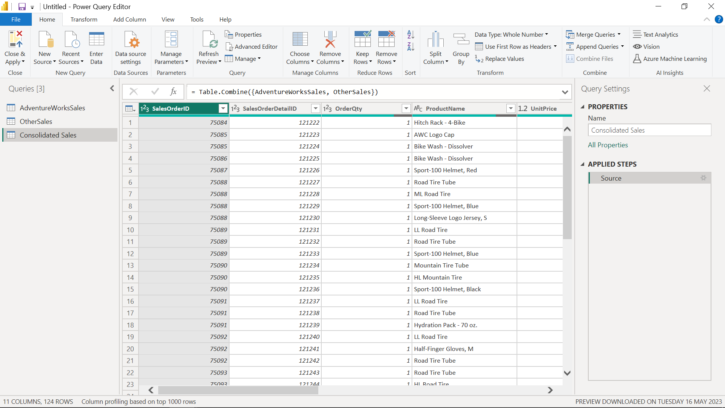

**Conclusion**

Your objective for this exercise was to apply techniques for importing, formatting, and combining data. In this context, you learned how to use Power Query Editor to import more than one data source, change the names or formats of the columns when needed before appending, append tables and queries, and create a new combined master table with a given name.